Dear Parents, Welcome back!

Our theme for Religion this half term is ‘Ourselves’

***“As God’s chosen ones, holy and beloved, clothe yourselves with compassion, kindness, humility, meekness and patience. Bear with one another and, if anyone has a complaint against another, forgive each other; just as the Lord has forgiven you, so you must also forgive. Above all clothe yourselves with love, which binds everything together in perfect harmony. And let the peace of Christ rule in your hearts, to which indeed you were called in the one body.” (Colossians 3: 12-15)***

Throughout this half term we will be exploring who we are. What are our special gifts and characteristics? What great talents do we have? How can we use our qualities and talents for good in the world?

‘Our topic theme is ‘**That’s Settled!’** based upon Anglo-Saxon Britain.

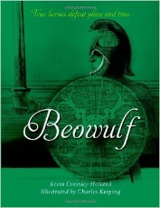

**English:** Our English work will be based around the text of ‘**Beowulf’ by Kevin Crossley Holland**. This is the story of a young man who travelled far across the sea to fight two terrifying monsters-one who could rip a man apart and drink his blood, the other who lived like a sea-wolf at the bottom of a dark, blood-stained lake. His name was Beowulf, and his story was written down in **Anglo-Saxon** in the eighth century. Kevin Crossley-Holland retells the story for children in strong, rhythmical prose, with striking illustrations by Charles Keeping!

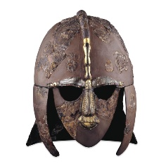**History:** ‘**The Anglo Saxons and Scots’**

Our studies in this area will further immerse us in how the invaders and settlers affected a post Roman Britain. We will learn how to study the archaeological evidence at Sutton Hoo and to ask and answer questions. Using a range of historical sources, we will find out who the Anglo Saxons were and where they came from. We will also find out who the Picts and Scots were and where they came from. In addition we will explore Anglo-Saxon culture including art, music, legends and poetry.

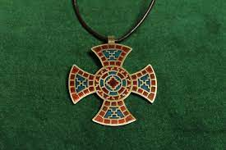**Art and DT**

We will learn about great craft makers and understand the historical development of their art forms. We will select from a range of materials to design and make replica Anglo-Saxon Jewellery.

In **Science** we will be investigating fabulous forces; what is the role of gravity? What are opposing forces? Is friction useful? What do air and water resistance do?

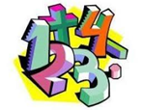In **Maths** we will be developing our work on place value dealing with increasingly large numbers; multiplication and division, including formal written methods; as well as, written methods for addition and subtraction. We will also be continuing with My Maths homework.

Other important notes for the academic year;

**Reading** is one of our utmost priorities in the school, and our aim is to instil a passion for reading in our pupils. Reading books will be sent home in a plastic wallet and changed as necessary. To support us with this, it would be beneficial to read with your child for around 10-15 minutes per night.

**Spelling, My Maths homework**: will be given out weekly and tested the following week.

**PE:**

PE days for **Class 11** are Tuesdays and Fridays

PE days for **Class 12** are Tuesdays and Fridays

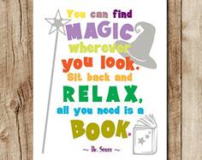Please send your child to school in their PE kits on these days.

By the end of the topic, we hope that your child will have achieved in all areas of the curriculum and that they have had an enjoyable time in the classroom. We hope too that you will have enjoyed seeing your child work with enthusiasm.

If you have any comments about the work your child has done, please get in touch.

Yours sincerely,

Mrs Franklin and Mrs Gore.