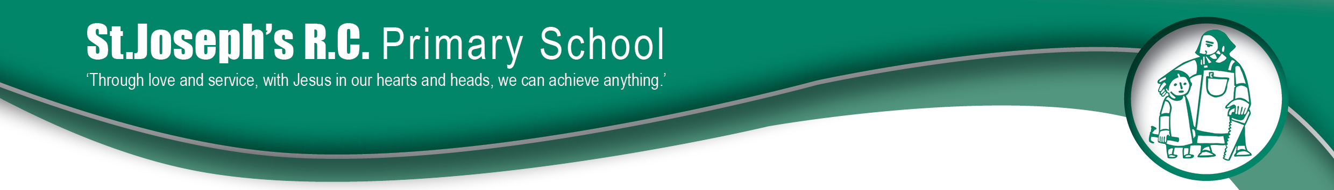
Summer Term - Year 2 Newsletter
A warm welcome back after the Easter break! We are looking forward to an action packed summer term.
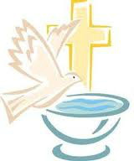
Religion:
This half term we will be focusing on Spreading the Word. The children will be able to retell the story of Jesus’ resurrection and ascension. They will learn that Jesus promised to send down the Holy Spirit and how the disciples changed because of this. The children will be able to make important links between the story of Pentecost and spreading the Good News. Year 2 will also discuss ways in which they can spread the Good News in daily life.
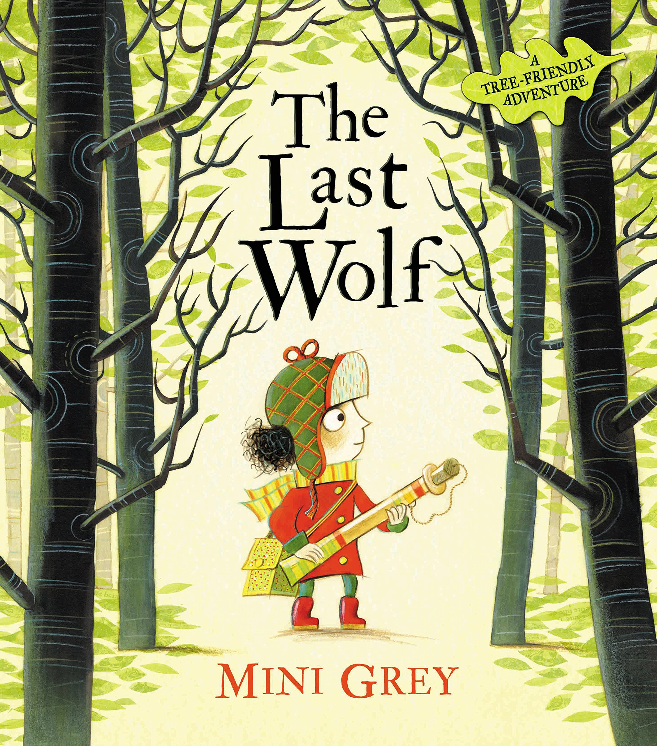
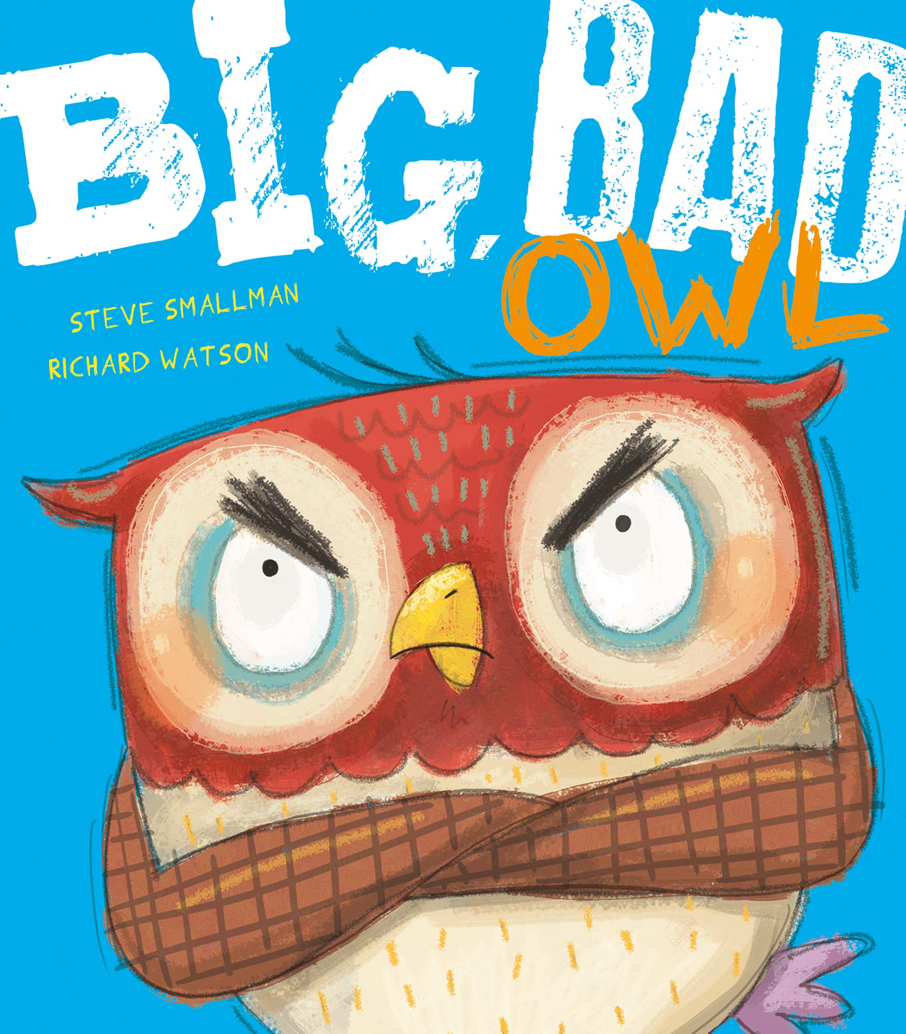
English:
This half term in English we will be reading and using the following texts as a stimulus for writing:
• You Choose Fairytales by Nick Sharrat and Pippa Goodhart
• The Last Wolf by Mini Grey
• Little Red Reading Hood by Lucy Rowland
• Big Bad Owl by Steve Smallman
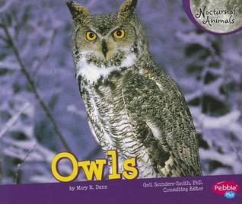
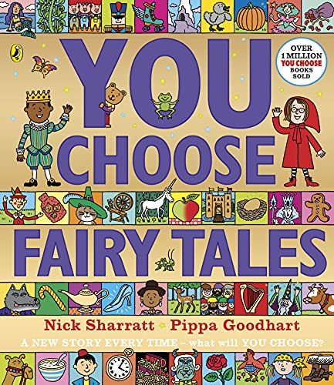
• Owls by Mary R. Dunn
This half term, we will be writing alternative versions of Little Red Riding Hood, looking closely at how we can improve our content and use of language. We will think about character development, settings and plot. We will be focusing on our past tense, our use of expanded noun phrases and questions and we will also complete some diary writing and letter writing focusing on the use of conjunctions. Finally, we will write information texts about owls.
Spelling, punctuation and grammar:
Year 2 will be focusing upon spelling the common exception words, the use of descriptive vocabulary, simple punctuation marks, handwriting and grammar. The children will address these targets through stories and explanation writing over the term.
Reading will continue to be a crucial part of our learning. It is essential that the children are able to recognise and spell common exception words alongside using their phonic knowledge to improve both their reading and writing. We encourage the children to read as much as possible and to discuss the text to further develop their comprehension skills. Please continue to support your children in achieving their reading awards by reading at home each day.
Phonics:
Focused phonic sessions will continue to be taught every day throughout this half term. Spelling homework will include a mixture of words based on these phonics sessions, in addition to common exception words. Please continue to practise spellings with your child every day at home so that they are able to apply it throughout their learning.

Maths:
The children will continue to develop their calculation skills through addition and subtraction, as well as continue to complete their weekly mental arithmetic challenge ‘Rapid Ralph’. Our first unit will be looking at fractions; recognising them, looking at unit and non-unit fractions and finally learning to count in fractions up to a whole. Children will also learn how to tell the time in five-minute intervals.
Topic: This term we will be exploring the topic of ‘Forest Fun’.
Art and Design: We will be exploring this topic by visiting Delamere Forest and using natural materials found outdoors to help us create our artwork. We will then invite a local artist in to complete some watercolour artwork with our children.
Geography: This term the children will be interpreting a range of sources of geographical information, including maps, diagrams, globes, aerial photographs focusing on our local area. We will then use simple fieldwork and observational skills to study the geography of our school and its grounds and the key human and physical features of its surrounding environment. Whilst studying our local area we will use simple compass directions (North, South, East and West) and locational and directional language [for example, near and far; left and right], to describe the location of features and routes on a map.

Science: This half term we will be exploring our topic of ‘Forest Fun’ by finding out and describing how plants need water, light and a suitable temperature to grow and thrive. We will be growing our own plants in class and recording the growth process and the things we need to do to keep plants healthy. Children will observe and describe how seeds and bulbs grow into mature plants.


PE:
This half term classes 5 and 6 will be having PE on -
Class 5 (Miss McQuaid): Wednesday and Thursday
Class 6 (Mrs Bellett): Monday and Friday
Please ensure your child wears their full PE kit to school for P.E.

Homework:
Reading – please continue to read as often as possible with your child and ensure that reading records and reading books are in school every day.
The Reading Championship will continue this term. Please be aware that books will only be changed if reading records have been signed by an adult. Good luck everybody, let’s continue reading!
Spellings – please continue to practise weekly spellings and common exception words every day with your child. Both classes have their spelling test on a Friday.

As we enter our summer term, please ensure your child comes to school with a water bottle to stay hydrated in the warmer weather. Sun hats can also be sent to help your child stay protected when they are outside in the sun. Please ensure sun cream has been applied before school and that your child can re-apply it independently if necessary.
We hope that your children enjoys exploring our new topic this term.
Yours Sincerely,
Miss McQuaid and Mrs Bellett

