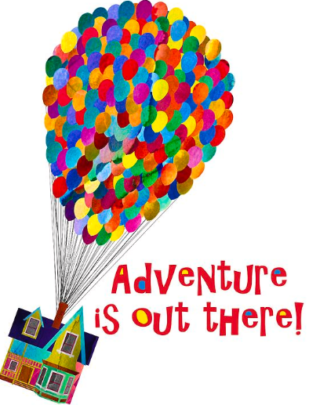

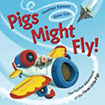
Year 2 – Autumn 2 – Adventure is out there!
‘

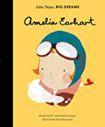
Dear Parents and Carers,
We welcome the children back after half term and look forward to starting our new topic ‘Adventure is out there!’ based around a range of texts about flight. We have a very exciting half term ahead of us and want to continue building on the excellent progress the children made last half term.
Religion
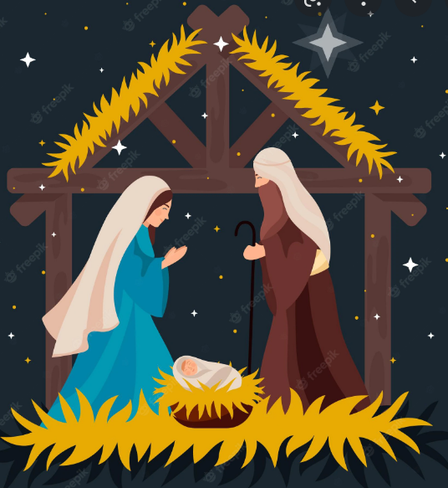
This half term we will be learning about signs and symbols. The children will be learning how to distinguish the difference between signs and symbols in everyday life. We will also be learning about the Sacrament of Baptism and the symbols used to represent the welcome, the Word of God, water, the oil of chrism, the white garment and the baptismal candle.
As we approach the festive season, we will participate in a range of special celebrations and Masses in preparation for the Coming of Christ. We will also mark other important days in our liturgical calendar such as All Saints and All Souls, as well as Remembrance. Advent bags will also be in circulation. Please do send us your photographs via the school office email if your child is chosen to bring it home to share with family members. Engagement in prayer at home is an important part of our school community’s journey of faith together.
English
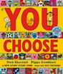
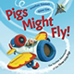
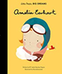
We have carefully selected different texts to teach through; these are all linked to our theme of aviation and exploration.

We will be using expanded noun phrases to name and list various transportation. The children will write diary accounts from the wolf’s point of view using the story, ‘Pigs Might Fly’ as a stimulus. We will also write recounts of Amelia Earhart’s life using past tense verbs.
In Year 2, we will be focusing on spelling the common exception words, the use of descriptive vocabulary, simple punctuation marks and handwriting. The children will address these targets through multiple genres of writing.
Reading will continue to be a crucial part of our learning. It is essential that the children are able to recognise and spell common exception words, as well as using their phonics knowledge to improve both their reading and writing. We are encouraging the children to read as much as possible and to discuss the text, to further develop their comprehension skills.
Please continue to support your children in achieving their reading awards by reading at home each day.

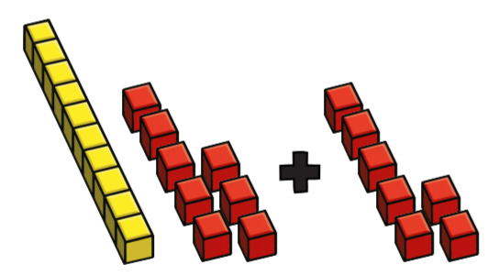
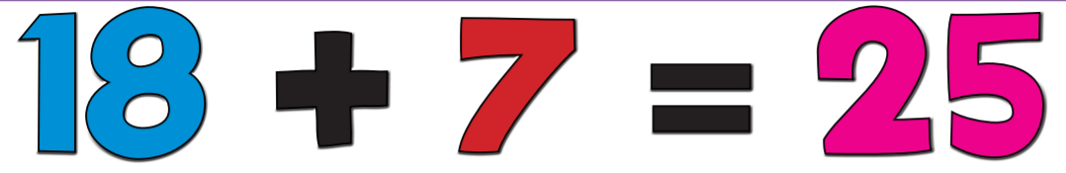
Maths
In Maths we will be focusing on the value of numbers to 100 using concrete apparatus and pictorial representations. Year 2 will also learn strategies for addition and subtraction using concrete objects to support them. The children will be consolidating their knowledge of time to be able to read the time in 15 minute intervals. They will also be working on coin recognition and shape.
Mental maths will include counting in 2s, 3’s, 5s and 10s and subtraction facts to 10 and 20. The children will be working hard to develop their problem solving skills too. Each week they will be challenged to use their reasoning skills and justify solutions to problems through detailed explanation.
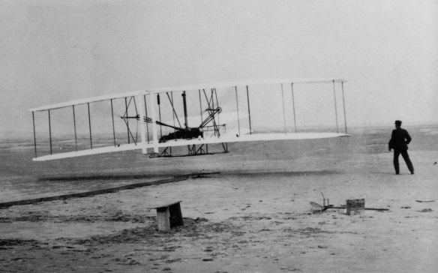
History- This half term, we will be comparing flight transport now and in the past. Also, the children will learn to sequence flight transport into chronological order on a timeline and find out about the first aeroplane flights. They will also learn about the lives of the Wright brothers and Amelia Earhart.

Art/DT: We will be designing and making paper aeroplanes which we will then fly outside.
Computing: This half term in Computing, the children will be learning about programming. They will understand what algorithms are and follow simple but precise instructions to program a bee-bot. Year 2 will also learn how to program using the Scratch Junior App.

Science: In Science we will be learning about ‘Living Things and their Habitats’. The children will be able to identify things that are living, things that are dead and things that have never been alive. They will learn how living things need to survive in a suitable habitat. The children will explore micro-habitats and food chains.
PE.:
Class 5 (Miss McQuaid): Thursday and Friday
Class 6 (Mrs Horrocks): Monday and Wednesday
Please ensure your child wears their full PE kit to school on their PE days. PE will often be taught outside so please ensure that your child dresses appropriately for the weather.
Homework
Reading – please continue to read as often as possible with your child and ensure that reading records and reading books are in school every day. Please be aware that books will only be changed if reading records have been signed by an adult. Good luck everybody, let’s get reading!
Spelling- please continue to encourage your child to practice spellings using the Spelling Shed website.

We hope that your children enjoy exploring our topic.
Yours Sincerely,
Miss McQuaid and Mrs Horrocks

