Spring 2
Dear Parents,
We welcome the children back after half term and look forward to starting our new topic ‘Go Wild!’
Our learning will be based around our quality texts ‘Where The Wild Things Are’ by Maurice Sendak, ‘Bedtime for Monsters’ by Ed Vere, , ‘The Ravenous Beast’ by Niamh Sharkey and ‘Explorers – My First Heroes’.
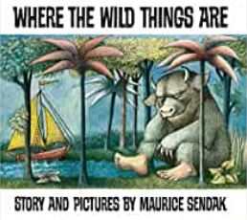
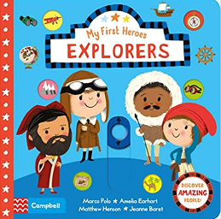
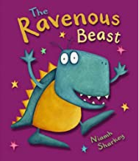
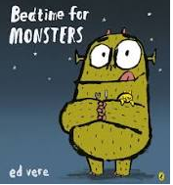

RE
As we journey towards the most significant Catholic festival of Easter, our RE will focus upon the changes we would like to make during Lent; the significance of Holy Week and ultimately the joy of Easter Sunday. We will not only study the story of Jesus from Palm Sunday to Easter Sunday but we will think about what these stories mean for us as Christians.
English
In English this half term we will be concentrating on finger spaces, capital letters and full stops, adjectives and conjunctions. The children will address these targets through story writing and writing historical facts.
Reading will continue to be a crucial part of our learning. It is essential that the children are able to recognise and spell common exception words as well as using phonic knowledge to improve both reading and writing. We are encouraging the children to read as much as possible and to discuss the text, to further develop their comprehension skills. Please continue to support your children in achieving their reading awards by reading at home each day.
Focused phonics sessions will take place every day. Please encourage your children to apply their phonics knowledge to their reading by sounding out and blending words they are unsure of.
Maths
In maths we are currently focussing on numbers from 50 to 100. We are reading and saying these numbers; representing these numbers using a variety of resources such as base 10; and adding and subtracting within 50 using drawings of tens and ones to help us. This term we will also be learning about length, height, mass and volume. Please spend as much time as you can practising the life skills of using the language of weight, length and capacity at home. The children will be working hard to develop their problem solving skills too. Each week they will be challenged to use their reasoning skills and justify solutions to problems through detailed explanation.

Topic
History: We will be researching significant individuals from the past and looking at their achievements. We will be comparing the lives of explorers Christopher Columbus and Robert Falcon Scott, looking at their lives and the impact they have made.
Geography: We will continue developing our knowledge of the seven continents and add knowledge of the world’s five oceans. We will also be learning about the location of hot and cold countries of the world. We will be using maps, atlases and globes to develop our understanding.
Art: We will be studying the work of Georges Seurat, looking at the similarities and differences between different pieces of his work. We will use his pointillism technique to create our own artwork, considering colour, shape and texture.
Science
This term we will be learning all about animals. We will be identifying and classifying different species and which animal group they belong to. We will be learning about the different characteristics each animal group have, their diets and sleeping habits.
PE
This half term classes 3 and 4 will have PE on Wednesdays and Thursdays.
Please ensure your child wears their full PE kit on these days. For safety, please ensure that long hair is tied back and earrings are removed.
Homework
Reading – Please continue to read every day with your child. Books will only be changed if reading records have been signed by an adult.
Handwriting Books – Handwriting books will continue this half term. Examples of the letter formation rhymes we use in class and how the letters should look on guidelines can be found at the front of the book. Please continue to support your child by practising their letter formation at home.

We hope that your children enjoy exploring our new topic.
The Year 1 team

