**Year 5 Summer Term 1 Newsletter.**

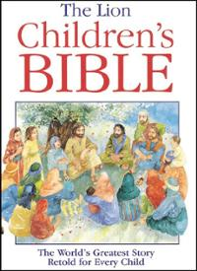 In **RE** we will be continuing with our “Come and See” scheme of work and we will be focusing on Transformation. We will explore the way we treat others, through our words and actions.

Our text for this term is **‘’The Midnight Hour” –by Benjamin Reid and Laura Trinder.** This magical book is about afantastic adventure set in a Victorian London frozen in time. It features a cast of Ghibli-esque characters, a feisty heroine and a hedgehog.

In **English**, we will be looking at diary writing and learning how to write an action packed narrative.

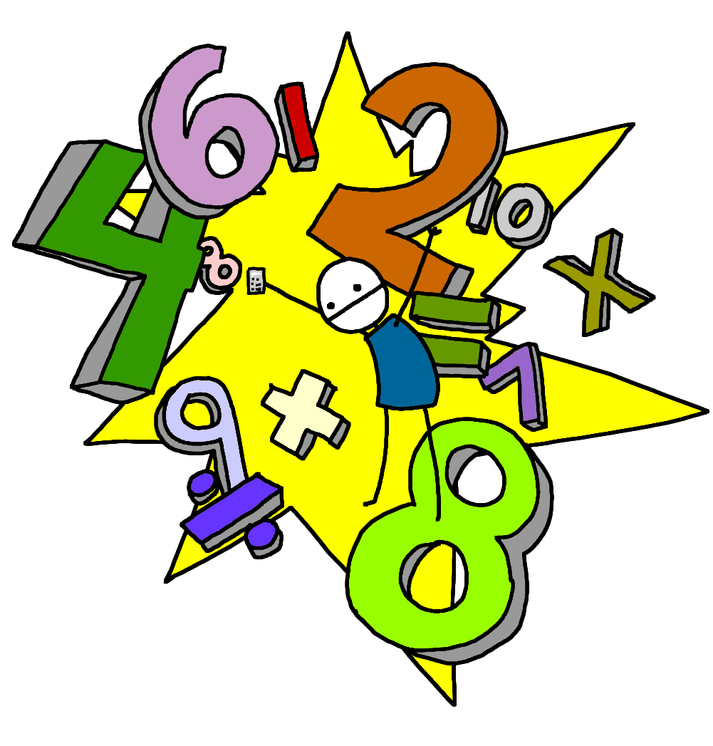

[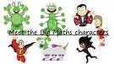](http://www.google.co.uk/url?url=http://www.westcliffeprimary.com/curriculum/big-maths/&rct=j&frm=1&q=&esrc=s&sa=U&ei=G5OeVZriDIyv7Aby75GYCQ&ved=0CBoQ9QEwAg&usg=AFQjCNFPO2JgmRr26SPuq3-6ZVvgRPpGsw)In **Mathematics** this half term, we will begin by looking at Shape. We will be focusing on the properties of 3D shapes. We will also be learning about position and direction, learning how to translate, rotate and reflect shapes.

Our **Science** this half term will focus on **Plants and Living things.**

We will be learning how to describe the differences in the life cycles of a mammal, an amphibian, an insect and a bird and looking at the life process of reproduction in some plants and animals.

Our **Topic** lessons this half term will look into ‘The Changing Power of the Monarchy’. We will learn about the relationship between King John and his barons and the signing of the Magna Carta and explore how the monarchy lost power over time. We will also learn about the life of Queen Victoria.

In **DT** we will investigate and analyse a range of existing ‘green’ inventions and design our own ‘green’ product.

**Spelling.**

Spellings will be uploaded onto **Spelling Shed** on a weekly basis and will be tested on a Friday.

Please ensure your child practises at home. Spelling is a vital part of learning to become a competent writer. It is a very important life skill that we value highly here at St Joseph’s so please support your child with this and encourage them to learn their spellings each week.

**Reading-** is one of our priorities in school, and our aim is to instil a passion for reading in our pupils. Reading books will be sent home and changed as necessary. Please ensure your child has their reading book and diary with them every day. To support us with this, it would be beneficial to read with your child for around 10-15 minutes per night.

Children will also receive Maths homework on the MyMaths website, which children have individual logins for.

Children have also been given their own login to Times Table Rockstars. Please encourage your child to practice their times table knowledge.

**P.E. in Year 5.**

Class 11 have PE on Tuesdays and Fridays.

Class 12 have PE on Tuesdays and Thursdays.

Please ensure your child comes to school in their PE kit on these days. During the cold weather months children are able to wear suitable outdoor sports clothing for PE (long tracksuit pants and school jumper)

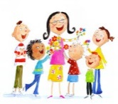We hope that your children have an exciting and enjoyable time with us this half term and that they are filled with enthusiasm for their learning. We are looking forward seeing the children grow, develop and progress in their learning.

Yours sincerely,

Mrs Franklin and Mrs Gore.