**Year 4 Spring 2 Newsletter**

During this term, our new topic will be ‘**Water Worlds’**! A topic which, as the title suggests, focuses on everything to do with **water**; from the study of rivers, to the water cycle. We will even be investigating the great **Sir Francis Drake,** a Tudor explorer famous for his watery voyages of discovery**!** Within this topic we will be focusing on History, Geography, Science and Art.

Through our **Religious lessons,** we will be focusing on **Lent**. In the Christian community, Lent is a time to prepare for Easter. It is a time of spiritual growth.   
We will be exploring how if we want to be followers of God we must be prepared to help others. We will be supporting the children in their Lenten promises and their almsgiving during Lent, supporting their faith journey to help bring them closer to God.

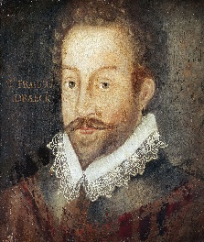In **History,** we will be learning all about Tudor water exploration, the reasons why they deemed their voyages so important, and why Sir Francis Drake (in particular) was key to Tudor exploration.



In **Geography,** we are going to find out about rivers and how they erode, transport and deposit materials. We will find out why rivers are important. We will investigate the causes of river pollution and the effect it has on the environment. We are also going to investigate a river in detail, including the effects on the environment and landscape.

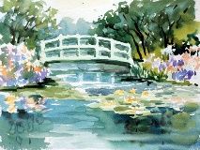In **Art**, we will be improving our mastery of art and design techniques, including drawing and painting. We will be studying the painter; Monet and looking at local water colour artists too!

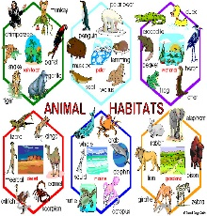In **Science**, our learning will be based on **‘Living things and their habitats’.** Pupils will be taught to classify, group and name animals in a number of ways, including looking at their natural environments. We will also construct and interpret a variety of food chains, identifying producers, predators and prey.

Our ‘Water World’ studies will not just be limited to our foundation subject studies. Our **English** will be based around the text ‘A River’ by by Marc Martin, as well as the use of another beautiful and enriching text, ‘Once Upon a Raindrop’ by James Carter and a variety of non-fiction texts from our Text Tubs.

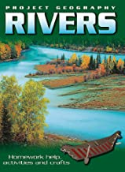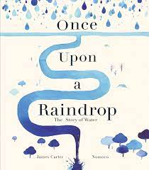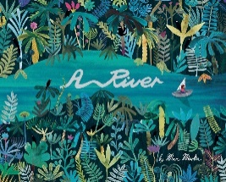

In **Maths**, we will be developing our mental calculation strategies and learning transferring our knowledge of fractions and applying this to decimals. Homework will be set on MyMaths.co.uk and will mirror what we have been learning in class. We will continue to perfect our time table knowledge. Get practising at home everyone!

**P.E. in Year 4.**

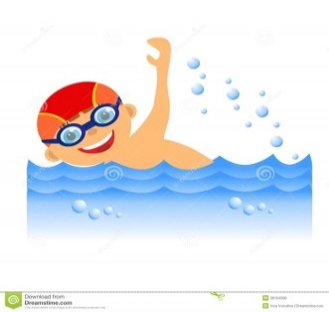Please ensure your child has their PE kit in school on the following days:

Class 9 – Monday and Friday

Class 10- Monday (P.E.) and Thursday (swimming)

**Class 10** will continue with their swimming lessons every Thursday, so please make sure that they bring their swimming kits with them.

We hope that your children have an exciting and enjoyable time this half term and that they are filled with enthusiasm for their learning. We are looking forward to seeing the children grow, develop and progress in their learning.

Yours sincerely,

**The Year 4 teaching team.**