

**Year 4 Autumn 2 Newsletter**

A warm welcome back after a restful week. This half term, we have lots of exciting things lined up for you! Our topic for this half term is ‘**Lighting it Up!’**

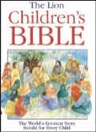

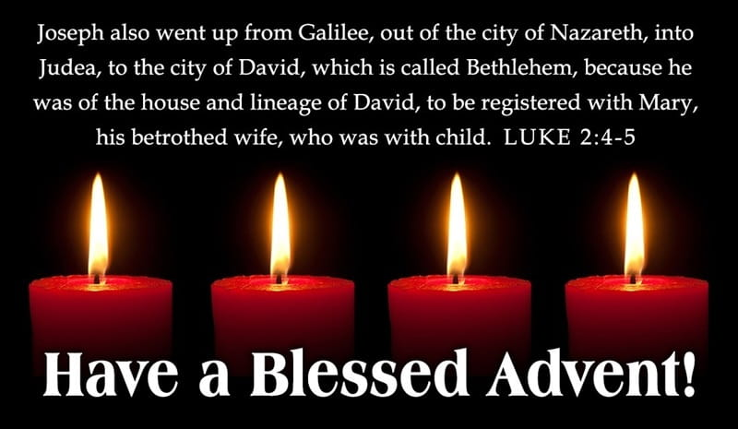 In Religion, we will be starting our unit ‘Baptism/Confirmation – Belonging: Called’ where the children will explore the idea that everyone is called at some point or another by God. The children will spend some time remembering, celebrating and responding to being chosen and also look at the Sacrament of Confirmation: a call to witness. As we move through the half term, we will be looking at Advent and preparing for Christmas.

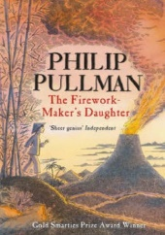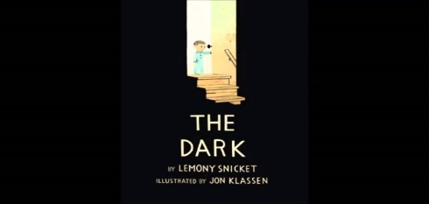

In **English** we are using the novels ‘The Firework Maker’s Daughter’ by Phillip Pullman, ‘Orion and the Dark’ by Emma Yarlett and ‘The Dark’ by Lemony Snickett. As well as developing our reading and inference skills, and enjoying these texts, we will use the stories as a stimulus for developing our narrative writing, descriptive writing and also, within these, our sentence structure.

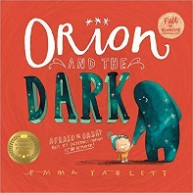



In our **Geography** topic, we will be looking at the position of Earth which creates day and night. We’ll then be taking a closer look at Earth by looking at the seven continents, as well as the Antarctic and Arctic circles. We’ll locate the equator and northern and southern hemispheres, as well as the Tropics of Cancer and Capricorn.

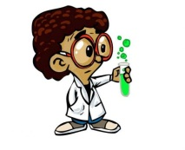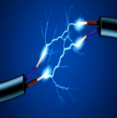Our Science topic is **“Electricity.”** We will be learning to:

* Identify common appliances that run on electricity
* Construct a simple series electrical circuit, identifying and naming its basic parts, including cells, wires, bulbs, switches and buzzers
* Identify whether or not a lamp will light in a simple series circuit, based on whether or not the lamp is part of a complete loop with a battery
* Recognise that a switch opens and closes a circuit and associate this with whether or not a lamp lights in a simple series circuit
* Recognise some common conductors and insulators, and associate metals with being good conductors.

Through our Science topic we will be engaging in a lot of research to develop our scientific understanding.

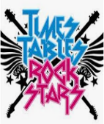

In **Maths** this half term, we will be working on area, multiplication and division. We will also continue to work on ‘Timestables Rockstars’, which is designed to improve children’s understanding of the times tables. We ask for your help in ensuring that your child continues to utilise this app at home. ‘My Maths’ will continue to be used to support the children’s learning at home also.

In **design and technology**, we are going to be designing and making our own nativity scene during Advent. Closer to the time, we will be asking for donations of small household items such as cereal boxes, shoe boxes, etc. This will be closely linked to our **computing** objective for the term ‘We are Toy Designers.’

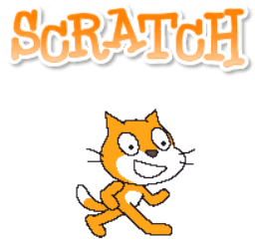

We will use the computer system ‘Scratch’ to design our nativity scene and decide upon the inputs and outputs for the nativity scene that we will be making. Additionally, this project will then be used for children to write a set of instructions detailing how to make the nativity scene.

**P.E. in Year 4**

Class 10’s PE is on Monday and Tuesday.

Class 9 will have PE on Monday and will continue with their swimming lessons every Thursday, so please make sure that they bring their swimming kits with them.

We are continuing to ask all children to come in to school dressed ready for PE. Expectation is that the children will wear their full school PE kit. Outdoor PE kit can be worn as the weather changes. The children wear their uniform on the day they go swimming and bring their swimming kit to school with them.

Yours sincerely,

Mr Cunningham and Mr Callaghan