

ST JOSEPH’S RC
PRIMARY SCHOOL

Writing Policy –
January 2023

Introduction

At St. Joseph’s, our EYFS classes follow the 2021 statutory framework of the EYFS and our KS1 and 2 settings follow the curriculum as outlined in the 2014 National Curriculum.

The intent for English is to promote high standards of language and literacy by equipping pupils with a strong command of the spoken and written word, and to develop their love of literature through widespread reading for enjoyment.
Our intent is to ensure that all pupils:
- communicate with confidence, have an ever-growing vocabulary and a firm grasp of the English language
- read easily, fluently and with good understanding
- develop the habit of reading widely and often, for both pleasure and information
- acquire a wide vocabulary, an understanding of grammar and knowledge of linguistic conventions for reading, writing and spoken language
- appreciate our rich and varied literary heritage
- write clearly, accurately and coherently, adapting their language and style in and for a range of contexts, purposes and audiences
- use discussion in order to learn; they should be able to elaborate and explain clearly their understanding and ideas

Curriculum Planning
English is a core subject in the National Curriculum and we carry out the curriculum planning in Literacy in three phases (long-term, medium term/short term). The long-term plan is topic based with a quality text at the heart of it. This allows staff to immerse their children in the topic, teaching appropriately linked genres of writing to give context and a deepening understanding of the importance of writing. Our medium-term/short term plans are adapted from the LTP and give details of the main teaching objectives for each unit. These plans define what we teach, and ensure an appropriate balance and distribution of work across each unit covering a range of fiction and non-fiction genres.

Plans also include a text map, ensuring the full potential of the text is explored, and a weekly short-term plan, which details the objectives and the learning activities, including support, where appropriate. This is followed up by a teacher assessment of the session against the learning objectives and a completed feedback sheet (see marking and feedback policy) to detail next steps.

Teaching and Learning
At St Joseph’s, we use a variety of teaching and learning styles in our English writing lessons in order to meet the needs of all our pupils.

How we teach Writing in the Early Years Foundation Stage:

In the Early Years, the development of children’s speech and language is at the heart of our curriculum and the starting point for our children’s steps in to writing. This, alongside the systematic daily teaching of phonics and the access to a range of continuous provision which promotes writing (both indoors and outdoors), provide a curriculum which promotes a love of language and literature.

In the Early Years, children are encouraged to attempt their own emergent writing and their efforts are valued and praised. As their phonic knowledge increases, this will be reflected in their writing. At the same time, their knowledge of key words is supported through reading and writing activities, including shared reading and writing.
A wide variety of opportunities are provided for children to engage in writing activities.
Amongst these are:
- Shared writing
- Role-play (e.g. an office or restaurant)
- Labels
- Recipes
- Lists
- Making books
- Writing letters
- Menus

Through engaging in these activities, children become aware that writing is used for a range of purposes. They distinguish it from drawing, and learn the left to right convention of writing in English.

Classroom practitioners also use direct teaching opportunities through the use of Talk for Writing (T4W), Tales Toolkit and Story Scribing. T4W is used in whole class instances across the curriculum. Discussion is modelled and structured. Using instances of T4W to support their independent growing knowledge of text, there is follow up use of Story Scribing which enables children to develop their independence in the writing process. Tales Toolkit is used with both the whole class and small groups. The scaffolds for this are promoted within the writing areas within the indoor continuous provision so that children can begin to independently use these when writing. Story Scribing is used as a follow up to Tales Toolkit also and allows children to fully express their ideas in writing and develop a true sense of achievement.

Speaking and Listening

Across the EYFS classrooms we also implement a range of strategies to support the development of the children’s speaking and listening. These include:
- Wellcom- a Speech and Language toolkit from screening to intervention.
- Kagan structures/turn and talk/shoulder partners
- Word Aware vocabulary grids

How we teach writing in Years 2 - 6:

Writing begins with a quality text at the heart of it. Staff are encouraged to immerse children in the text using creative hooks to stimulate a sense of awe and wonder. Staff are encouraged to use creative devices across lessons to bring their theme and text to life, make links across subject areas, thus allowing a meaningful and experiential curriculum for children. We use the quality text to ensure children understand how this is a model for their own writing – but not just how to replicate styles of writing, but to become confident writers who know what kinds of writing to adopt ‘at the right time’, thus writing purposefully. We aspire for our children to write coherently, confidently with the appropriate tone to make the writing they produce appropriate to the audience.

With the quality text and theme at the heart, we follow a phased support (see below) to enable to children to become independent in their writing – thus, become a confident and capable writer.
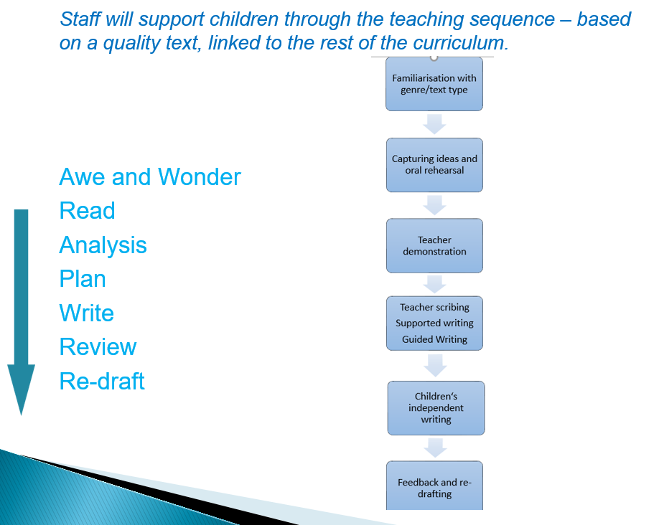

Phase 1 – Awareness

- Familiarisation with new quality text/genre type/vocabulary using Word Aware vocabulary grids to fully immerse and explore language with regard to its meaning and effect
- Deconstruction of genre – spot the features – authors’ style/techniques – this should inform the tone and register of writing (audience). The children learn what the purpose of the writing is.
- T4W – familiarisation of quality text/oral rehearsal/oral composition of sentences
- This is also supported by use of role-play, drama, songs and rhymes where appropriate.

Phase 2 – Teacher modelled and scaffolding of new skills

- Modelled writing – sentence stacking including use of GPS overview for complete coverage of NC grammar. This should also be used to introduce to the children the tone and correct use of formal/informal language. The adult, at this stage thinks aloud the writing process- editing as they write, explaining to the class why they have made changes.
- Shared writing – Adult leading the writing process (as in the modelled writing process) but asking the pupils for suggestions, ideas, vocabulary choices.
- Paired work- Kagan structures
- Guided writing – focusing on explicit curriculum and objectives personal to the children. The teacher will group pupils according to needs and gaps in learning.

Phase 3 – Independent application of new skills

- Hot Writes
- Use of assessment grids
- Re-drafting

Genre, Audience and Purpose

A range of writing genres have been mapped out in our long term planning. Coverage includes a balance of poetry, narrative and non-fiction text types. Teachers, when planning their writing sessions are to give consideration to the intended audience and purpose of the text and where it might sit in real life.

Grammar

The grammar expectations for each year group (Year 2-6) have been mapped out and link to the quality text and topic focus of each half term.
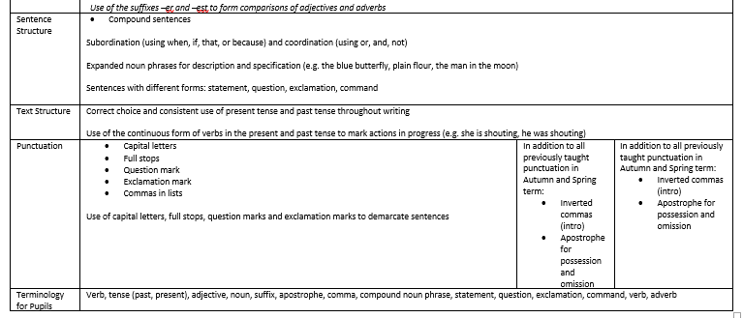

Grammar can be taught explicitly at the start of English lessons or as a separate session. Within these sessions it is expected that pupils practice constructing sentences and using punctuation to effect. These skills will then feed into their independent hot write task and ensure that writing is cohesive and structured.

“Sentence-level work is the engine that will propel your students from writing the way they speak to using the structures of written language.” Judith Hochman

Common grammatical errors, particular to the class or group can also be targeted and acted upon within these sessions.

Hot Write lessons

Hot Writes, demarcated with a red dot near the date.

The pieces of writing must be marked before the next taught English lesson and errors highlighted to the children using green symbols but they are not to be corrected for them. Misconceptions are recorded on a summary sheet and then dealt with during the next session.

The expectation is to complete 2 - 3 Hot Writes per half term.
(Year 6 have a separate book for independent writing tasks.)

In Years 2 to Year 6, Hot Write sessions are structured to allow for teachers and teaching assistants to provide timely feedback in the moment to support children in their writing.

In Year 2 and Year 3, teachers structure the session so that up to half of the class are writing at one time, providing opportunity for all to receive feedback. During this time the other half of the class are engaged in a GPS retrieval activity which can be completed independently and is adapted to the needs of each child. In Years 4 - 6 the children will all write at once and the adults within the room will circulate and provide timely feedback to support the children’s writing.

Assessing Writing

Early Years:

Summary sheets are completed for Phonics sessions across the week.
All staff take on the responsibility of ensuring that each child’s achievements are noted on Tapestry and / or recorded in their Learning Journey, building up a record of formative assessment.
Half termly phonics assessments are completed.
Verbal feedback and positive praise is an integral part of everyday practise.

Years 2 – 6:

Summary sheets are completed for every lesson.

Green comments only for spelling and punctuation (use symbols see marking policy). These corrections are then completed at the beginning of the next English lesson and demarcated in a different colour so that it is obvious that changes are independently made by the pupil.

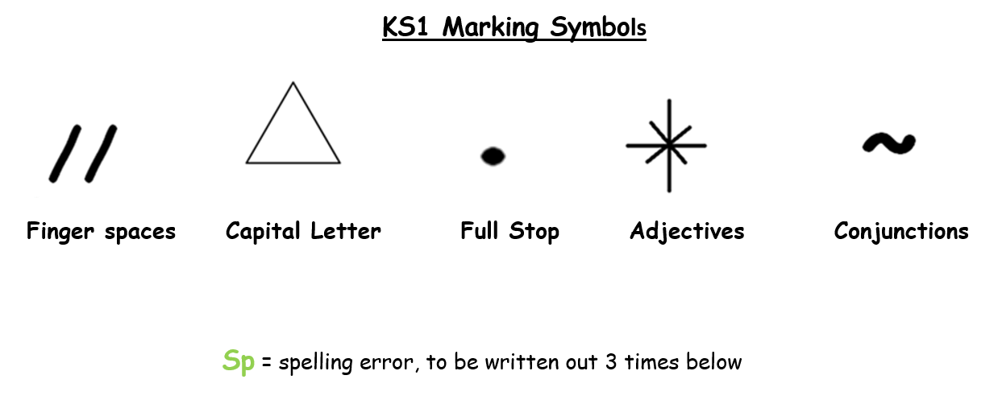

KS2 Marking Symbols
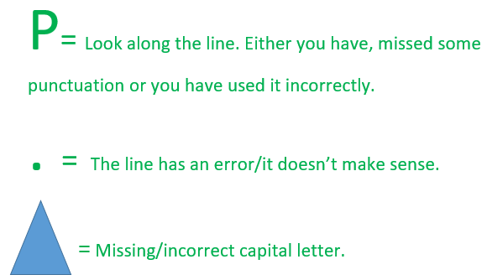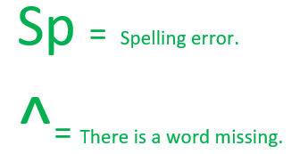

The next session after Hot Write must always be a re-drafting session and this can either be correcting all, or correcting part or rewriting and correcting and improving multiple parts.

Feedback must result in progress and identify errors or if the child does not understand (misconception). This will not be expected in Year 1 until the summer term; therefore, it must be addressed through a carousel adult centred approach in the moment of writing.

“Students need explicit instruction, including clear directions, teacher-led demonstrations, group participation and a careful sequence of activities to redraft their work effectively.” Judith Hochman

A redraft session in Y2 to Y6 is structured in the following way:

1. Share and discuss common misconceptions and errors with the whole class.
2. Model live editing to the whole class using a piece of work from within the class.
3. All children correct their errors using a coloured pencil crayon (orange pen in Y6).
4. All children re-write an identified part (or all) of their Hot Write.

The redrafted work (Years 2-6) is to be clearly identified, so that progress from the Hot Write and focused teaching on common errors and misconceptions is clear. Year 6 will use orange pens for this. Years 2-5 will complete it in pencil or pen and it can be glued over the section of the Hot Write (like a flap) if the teacher deems this appropriate and useful.

Assessment grids (for year groups 1, 3, 4 and 5) are updated on completion of Hot Writes. Year 2 and Year 6 assessment grids match the DfE standards for EoKS1 and EoKS2 writing expectations and these are to be dated and ticked when a child has evidenced the achievement of a particular standard.

‘Pieces of excellence’.

Once every half term the two lessons following a Hot Write must be focused on redrafting, plus two sessions from within the wider school day, so that a ‘piece of excellence’ is created by all children. The first two lessons will be part of English lessons, the first of which will follow the format above and the second of which will be further time to complete the ‘piece of excellence’. Where pupils need more time, the further two sessions must be identified by the class teacher within the wider school day - this may be required for all, or at times just some children.

The pieces of excellence will then be displayed in a communal area within school to celebrate writing.

In the Classroom

English:
- Sentence structure examples
- Punctuation types
- Alphabet/letter formation cues etc.

These general prompts should be up long-term.

Working Wall:
- There should be the front cover of the quality text/prompt to make it clear what your quality text is
- WAGELLs and key vocabulary based on the text and linked to what you expect the children to use – categorising approach from Word Aware could also be adapted here too
- Unfamiliar / new vocabulary should have definitions displayed also, these should be the definitions taught to the children and should not be deferred from
- Genre features/prompts
- Class shared writes/modelled story steps etc. use of flip charts to show ongoing writing process

Presentation and Handwriting

All teachers have high expectations in the presentation of work and follow the presentation and handwriting policies of the school. Please see separate policy for further details of how we teach and achieve this.

Spelling Shed
Year 2-6

From September 2021, here at St Joseph’s we have invested in a subscription to an online learning platform. Children in school will still have access to their regular taught phonics and spelling lessons, but they will now have access to the platform to practice at home.
So, what are the key points?
- Children have a weekly test for their spellings – this will take place in class and be assessed by their teachers.

- There will no longer be paper copies of spellings sent home. Everything is accessed online via Spelling Shed and children have their own logins to the site.

- As the children practise their spellings – they will collect points. These points will go up and down each week depending on how much they practise each set of spellings.

Contribution of Writing in other Curriculum areas

The skills that children develop are linked to and applied in every subject of our curriculum. The children’s skills in reading, writing, speaking and listening enable them to communicate and express themselves in all areas of their work at school.
High expectations of writing will be reflected across all areas of the curriculum and be evidenced in pupils books.

