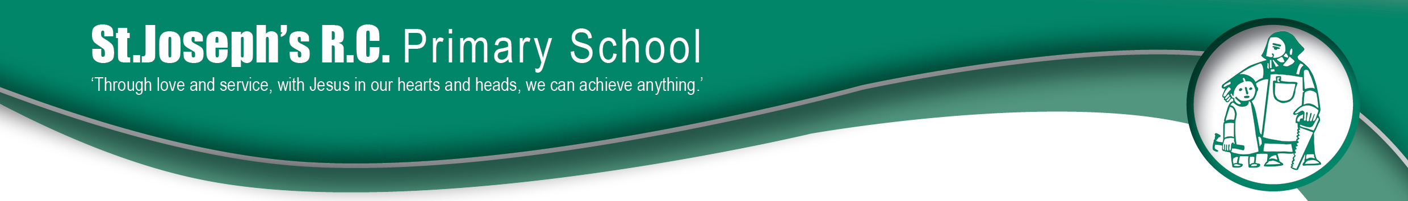

ST JOSEPH’S RC
PRIMARY SCHOOL

Reading Policy 2020

Aim of policy: To become an outstanding reading school.
(ref: ‘Building an Outstanding Reading school- Oxford Primary.)

We will:
- Place reading and books at the centre of the curriculum.
- Recognise that being able to read well is a key life skill for children, whatever their background.
- Believe that every child can learn to read with the right teaching and support.
- Acknowledge that not all children will have the opportunity to develop a love of reading at home, so this has to be taught and encouraged at school-just like any other are of the curriculum.
- Build time for all children to read independently, read aloud and be read to during the school day.
- Develop a coherent whole- school strategy for promoting reading for pleasure.
- Spend money and tine to support reading, including buying books and developing the school environment to support reading.
- Believe that every teacher should be an advocate for reading.
- Devote time to training to staff so they are equipped to support children’s enjoyment of reading.
- Involve parents to ensure the culture of reading that the school has developed extends into the home.
- Engage children to take control to develop a love and preference for reading styles/authors and genres.

At a reading school, all children learn to love books and the school is prepared to make this an absolute priority.

Reading:

Foundation Stage

- Base-line the children within the first two weeks of the new school year.
- Daily 20 minute discrete phonics session. (RWI)
- Differentiated phonics groups from Autumn 2 onwards. TAs to delivery one of these groups and feed-back weekly progress to class teachers. TA3s to plan these sessions, with support of the class teacher.
- After base-line - 2 x 1-1 reading per week (per child) – 1 teacher led and 1 TA led.
- Daily individual reading with TA for any child below age-related expectations.
- From Summer 1, 1 x GR with teacher for those at age related expectations – replaces teacher 1-1 reading

KS1
- Daily 20 minute discrete phonics session. (Letters and Sounds – supplemented by some resources from RWI)
- Differentiated phonics groups across the year group – pooling below age expected and teaching to their specific need. TAs to delivery to this group and feed-back weekly progress to class teachers. Class teachers to plan these sessions.
- 2 x GR sessions per week (per child) – 1 teacher led and 1 TA led.
- Individual reading to take place weekly for those above age expected and twice a week for those at age expected.
- Daily individual reading with TA for any child below age-related expectations.
- IDL access for those children who are below AR.
- Teachers should spend one week of every half term hearing individual readers in place of GR.

KS2
- Daily 20 minute discrete phonics session in LKS2 - for those children in Y3 who didn’t pass Phonics Screening check
- 1 x GR sessions per week (per child) – teacher led and x1 TA led
- Individual reading to take place weekly for those above age expected and at age expected.
- Daily individual reading with TA for any child below age-related expectations.
- IDL access for those children who are below AR.
- Y6 focus with Speech and Language consultant – focusing on vocabulary/direct word reading and inferences based on discussion/liaison with class teachers.
- Teachers should spend one week of every half term hearing individual readers in place of GR.

Guided reading occurs daily outside the literacy session and is based on a rotation throughout the week within the class. Children are grouped according to ability and when not involved in an adult led session the children are given a purposeful reading activity to complete independently which consist of a pre-reading task, post reading task and text tub, which further links to our ‘free reading’ and ‘Reading for Pleasure’ initiatives in school where children have the power to choose and develop their own preferences for reading.

Assessment of Reading
KS1 - Assessments of children’s phonic knowledge will be made half termly and strategies will be put in place to support children where necessary eg. change phonics groupings, additional phonics reading books, referral to SENCO or SALT. Staff to also assess children’s knowledge of high frequency words throughout the year and track individual progress through observations and testing.

Assessments are made weekly during guided reading sessions using Reading objective tracking grids (KS1/2) to track both group and individual progress. Next steps will be determined from the same tracking grids, in order to ensure progression. Formative assessment (teacher assessment) in the form of E, D, S, GD levels will be collected termly in KS1 and 2. This also needs to link directly to the appropriate colour banded reading book for each term in each academic year group.

Reading ages will also be tested in the first term of Autumn, Spring and Summer in KS1 and 2. This will follow using PIRA and direct data of children’s chronological reading ages to determine whether children are reading at an AR level will be input directly into O-Track. This will be completed in EYFS at the end of Summer 2.

