**Year 5 Spring Term 1 Newsletter.**

Welcome back and a Happy New Year! We hope you had a fantastic Christmas period and are looking forward to the exciting things lined up for you this term!

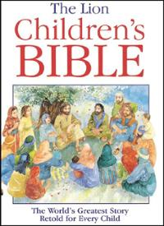

In **RE** we will be continuing with our “Come and See” scheme of work and we will be focusing on Our local community and the church that we are part of.

Our topic for this half term is all about **‘Rainforests’.**

Our text for this term is **‘The Explorer’ by Katherine Rundell.** We will be looking at character and setting descriptions as well as making predictions. It will not just be fictional that will be our focus however, we will be focussing closely on how to write a survival guide as well as biographies.

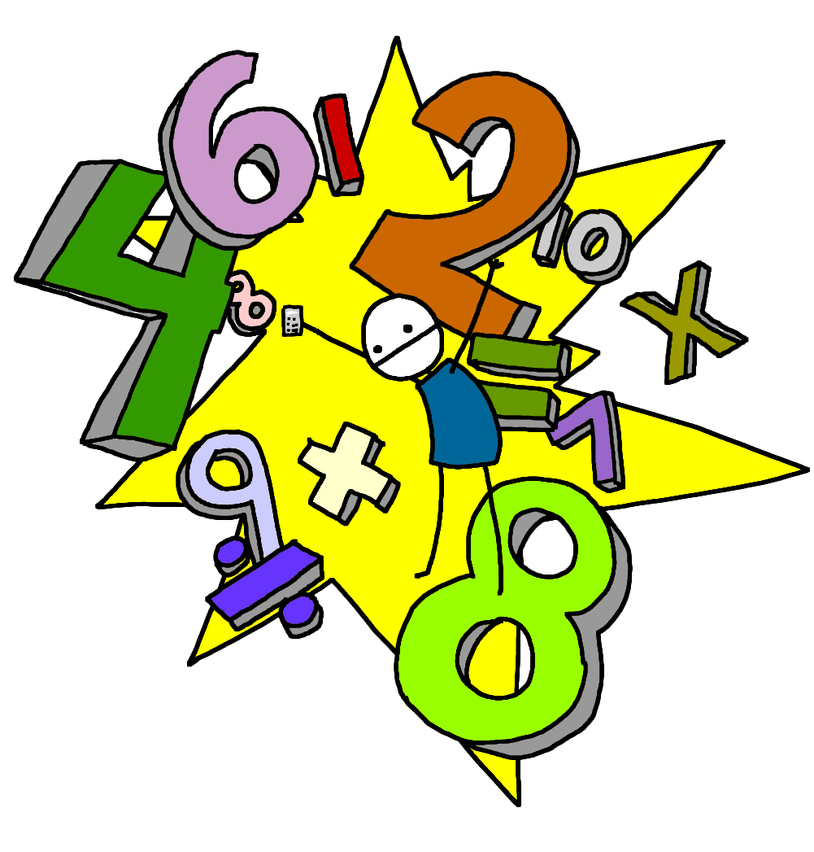

[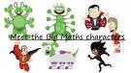](http://www.google.co.uk/url?url=http://www.westcliffeprimary.com/curriculum/big-maths/&rct=j&frm=1&q=&esrc=s&sa=U&ei=G5OeVZriDIyv7Aby75GYCQ&ved=0CBoQ9QEwAg&usg=AFQjCNFPO2JgmRr26SPuq3-6ZVvgRPpGsw)In **Mathematics** this half term, we will begin by looking at shape properties. We will continue to look at multiplication and division. We will also be learning about fractions - will be focusing on multiplying fractions and finding fractions of amounts.

Our **Topic** lessons this half term will look into tropical rainforest biomes and we will research deforestation and its impact on humans, animals and the weather,

In **Art**, we will be learning to generate, develop, model and communicate our ideas through discussion and annotated sketches. We will also be learning to select from and use, a wider range of materials when creating our own Amazon rainforest scene.

**Spelling.**

Spellings will be uploaded onto **Spelling Shed** on a weekly basis and will be tested on a Friday.

Please ensure your child practises at home. Spelling is a vital part of learning to become a competent writer. It is a very important life skill that we value highly here at St Joseph’s so please support your child with this and encourage them to learn their spellings each week.

**Reading-** is one of our priorities in school, and our aim is to instil a passion for reading in our pupils. Reading books will be sent home and changed as necessary. Please ensure your child has their reading book and diary with them every day. To support us with this, it would be beneficial to read with your child for around 10-15 minutes per night.

Children will also receive Maths homework on the MyMaths website, which children have individual logins for.

Children have also been given their own login to Times Table Rockstars. Please encourage your child to practice their times table knowledge.

**P.E. in Year 5.**

Class 11 have PE on Tuesdays and Fridays

Class 12 have PE on Wednesday and Thursdays.

Please ensure your child comes to school in their PE kit on these days. During the cold weather months children are able to wear suitable outdoor sports clothing for PE (Long tracksuit pants and jumper)

We hope that your children have an exciting and enjoyable time with us this half term and that they are filled with enthusiasm for their learning. We are looking forward seeing the children grow, develop and progress in their learning.

Yours sincerely,

Miss Farrelly and Mrs Gore.