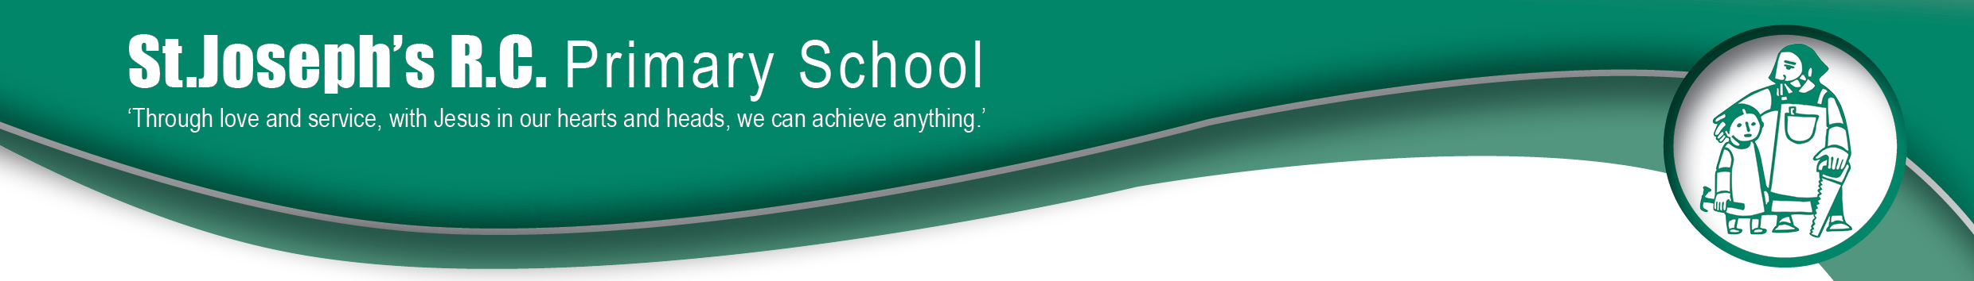
Friday 17th September 2021

Spelling Shed

Dear Parent/Carer,

As you know here at St Joseph’s we are committed to raising standards. This term we are making improvements to the way children learn how to spell.

One of the most valuable partnerships we have is between school and home. Like reading, spelling at home is one of the most important things that you can do with and for your child. Children being able to spell easily and rapidly supports their confidence and pace in writing.

School have therefore invested in purchasing a subscription to an online learning platform. Children in school will still have access to their regular taught phonics and spelling lessons in school, but they will now have access to the platform to practice at home.

The platform is called Spelling Shed and a tutorial video on how to access and navigate the site can be found by following: https://www.youtube.com/watch?v=uVHb4srs0RU&t=16s

So, what are the key points?
- Children will still have a weekly test for their spellings – this will take place in class and be assessed by their teachers like previously. Each teacher/class will confirm their chosen days for spelling tests.

- There will no longer be paper copies of spellings sent home – everything is accessed online via spelling shed.

- Children have been practising in class with their teachers how to use the site and their login cards will be sent home.

- As the children practise their spellings – they will collect avatar points. These points will go up and down each week depending on how much they practise each set of spellings.

- There is also a pdf guide that can help you to see how the children can challenge themselves at different levels whilst learning their spellings. https://s3.eu-west-2.amazonaws.com/files.edshed.com/docs/Parent+Guide+for+Spelling+Shed.pdf

We hope you enjoy supporting your child(ren) in this learning process and thank you for your continued support.

Miss R Mitchell
English Leader

