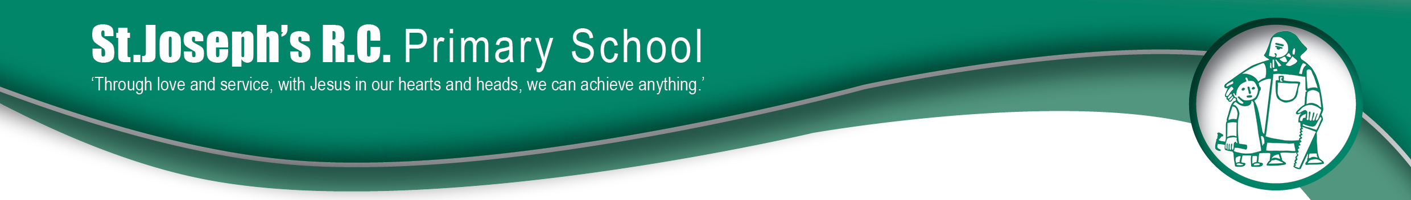
Wednesday 3rd April 2019
Dear Parent/Carer,

I am writing to inform you that our school is now part of Operation Encompass.

Operation Encompass is a Police and Education early intervention safeguarding partnership which supports children and young people exposed to domestic abuse.

Being part of this project means our school will receive a notification from Greater Manchester Police before the start of the next school day when a child or young person has been involved in or exposed to a domestic abuse incident the previous day. When incidents occur on a Friday, Saturday or a Sunday, the police will contact our school on the following Monday.

The information is given in confidence to the schools Key Adult and will enable support to be given dependant on the needs and wishes of the child.

The Key Adults at our school are myself, Mrs Dunne, and also Mrs Russell and Mrs Vernon. They have received a briefing about his project and the impact of Domestic Abuse on children and young people.

Our school always endeavour to offer the best support possible to our pupils and we are proud to be part of the Operation Encompass intervention as we believe this is a crucial way in which we can support the children and young people in our care.

Some information about Encompass is included in this letter but if you would like more information about this new initiative, full details of the policy can be found on Rochdale’s Safeguarding Board’s website www.rbscb.org

Thank you for your continued support,
Yours sincerely,

Mrs C Dunne
Head Teacher

