Dear Parents,

During this half term, those of us in Classes 11 and 12 will be following a topic which focuses on **Maps**.

Religion: Hope

“Christ’s whole earthly life – his words and deeds, his silences and sufferings, indeed his manner of being and speaking – is *Revelation* of the Father. Jesus can say: ‘Whoever has seen me has seen the Father’, and the Father can say: ‘This is my Son, my Chosen; listen to him!’ Because our Lord became man in order to do his Father’s will, even the least characteristics of his mysteries manifest ‘God’s love ... among us.” *(CCC516)*

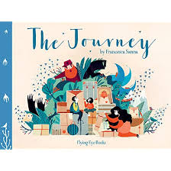******Throughout this half term we will be exploring the gifts that we have received as a sign of love. We will look at which gifts we treasure most and why do we treasure them. We will reflect on times in our lives when we have given ourselves to others and how this made us feel.

**English** : The Journey

We will be basing our English around the text ‘The Journey’ by Francesca Sanna. This beautifully illustrated picture book introduces a powerful and moving perspective on migration for readers of all ages. Told through the eyes of a young girl, the story explores the unimaginable decisions made as a mother and her two children who are forced to flee their home and everyone they know to escape the turmoil of war.

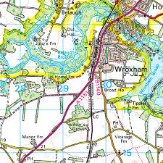In **geography**, we will be:

* Building on our map reading skills
* Using OS maps and symbols to create our own maps
* Using the eight points of a compass, four and six-figure grid references, symbols and key to build their knowledge of the United Kingdom and the wider world

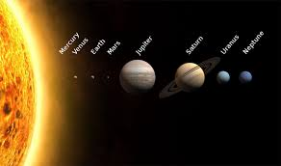

In **science** we will be investigating the Solar System; What are the planets? What is the order of the planets? Why do we have night and day? Why do we have the seasons? Why does the moon change shape?

In **art**, we can look forward to designing an art piece with stark colours to best represent space.

In **Maths** we will be developing our work on multiplication and division, including formal written methods. We will also be learning to find the perimeter and area of regular and irregular shapes. We will also be continuing with My Maths homework.

Other important notes for the academic year;

**Reading** is one of our up-most priorities in the school, and our aim is to instil a passion for reading in our pupils. Reading books will be sent home in a plastic wallet and changed as necessary. To support us with this, it would be beneficial to read with your child for around 10-15 minutes per night.

**Spelling, My Maths homework**: will be given out weekly and tested the following week.

**PE:**

PE days for **Class 11** are **Tuesdays** and **Fridays,** please send your child to school in their PE kits on these days.

**Class 12 PE** is on **Tuesdays** and **Thursdays,** please send your child to school in their PE kits on these days.

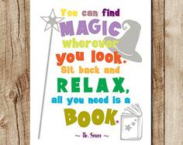By the end of the topic, we hope that your child will have achieved in all areas of the curriculum and that they have had an enjoyable time in the classroom. We hope too that you will have enjoyed seeing your child work with enthusiasm.

If you have any comments about the work your child has done, please get in touch.

Yours sincerely,

Mrs Franklin and Mrs Gore.