***Isaiah 54: 10 The mountains and hills may crumble, but my love for you will never end; I will keep for ever my promise of peace.***

Year 6

Autumn 1 Newsletter

Dear Parents,

I hope you all had a summer wonderful break! I’m sure your children looking forward to being in Year 6!

Our theme for **Religion** this half term is Family: Unconditional Love.

***“As God’s chosen ones, holy and beloved, clothe yourselves with compassion, kindness, humility, meekness and patience. Bear with one another and, if anyone has a complaint against another, forgive each other; just as the Lord has forgiven you, so you must also forgive. Above all clothe yourselves with love, which binds everything together in perfect harmony. And let the peace of Christ rule in your hearts, to which indeed you were called in the one body.” (Colossians 3: 12-15)***

We will be exploring the theme of ‘unconditional love’ and what this means for us. We will consider: How does Jesus show us unconditional love? How can we appreciate the love of those who care for us and how can we show care and love to others?

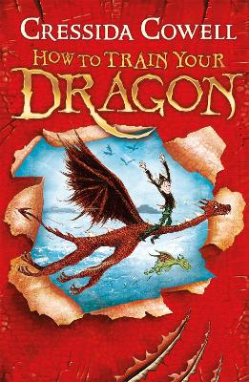

‘Our topic theme is ‘**Vicious Vikings!’** based upon Anglo-Saxon Britain.

**English:** Our English work will be based around the text of ‘**How to Train your Dragon’ by Cressida Cowell**. This is the story of a young Viking boy (Hiccup Horrendous Haddock III), the quiet and thoughtful son of the Chief of the Hairy Hooligans, as he tries to pass the important initiation test of his Viking clan by catching and training a dragon.

**History: The Vikings**

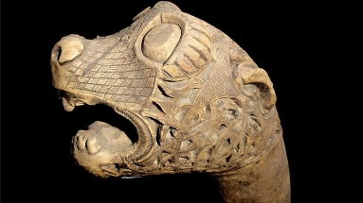Our studies in this area will further immerse us in how the invaders and settlers affected a post Roman Britain. We will learn how to study the archaeological evidence such as weapons, armour, jewellery and longships to ask and answer questions. Using a range of historical sources we will find out who the Vikings were and where they came from. We will also recap our Year 5 learning of Anglo-Saxons, Picts and Scots to support our understanding of what Britain was like during this time.

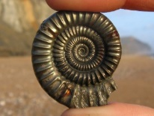**Science: Evolution and Inheritance** We will learn how to **r**ecognise that living things have changed over time and that fossils provide information about living things that inhabited the Earth millions of years ago. We will know how to recognise that living things produce offspring of the same kind, but normally offspring vary and are not identical to their parents. We will also learn how to identify how animals and plants are adapted to suit their environment in different ways and that adaptation may lead to evolution.

**Art and DT**

We will learn about great craft makers and understand the historical development of their art forms. We will select from a range of materials to design and make replica Viking Longship.

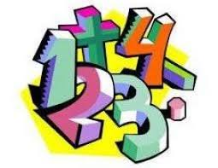In **Maths** we will be developing our work on place value, practical and written methods of addition, subtraction, multiplication and division and problem solving. It would be useful to ensure your child continues to practise times-tables so that they know them ‘off by heart’, as this is a fundamental skill, which is needed during Maths lessons. The children’s ‘My Maths’ homework will support the work we have been doing in class.

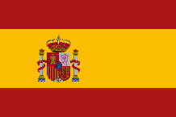

**Spanish**: This term we will be learning French vocabulary and phrases connected with: Greetings, recap of numbers, Months of the year and objects around school.

**Other important notes for the academic year:**

**Reading Championship-** How well did you do last year? How far did you get? Now you have the opportunity to better your achievements! Remember, reading EVERY night and have your diary signed, by an adult, every night. Good luck everyone and let’s get reading!

**Homework: My Maths:** Set every Friday to be completed for the following Friday.

**Spelling:** Will be given every Friday and will be tested the following Friday.

This year, PE for both Class 13 and Class 14 is on **Wednesday** and **Friday** – please ensure that your child comes to school dressed in their PE kit on these days.

**Thank You**

**Mr Green and Mr Parsonage**