**Year 4 Summer 1 Newsletter**

Welcome back after your Easter holiday! We hope you had a fantastic Easter break and are looking forward to the exciting things lined up for you this term!

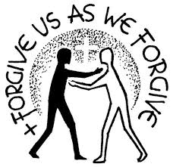

In our **Religion** we will be continuing to use our “Come and See” scheme and we will be looking at Pentecost and the importance of this season to Christians. Christians believe that the gift of the Holy Spirit within them gives them energy and the power to live the way Jesus taught us. We believe that the Spirit of God is active in each person and, in a special way, in the community of believers, which is the Church. It is the work of the Spirit to enable people to hear God’s message and to live Jesus’ way of service.

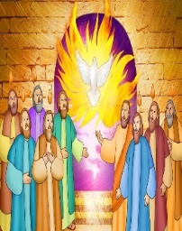

Our next unit will be ‘Building Bridges’. Christians believe that, in Jesus Christ, the world has been reconciled to God. Through and in Christ, every human being is offered the power to reach out in forgiveness and peace, to receive and to offer reconciliation. This will be the focus of our learning for some of this half term.

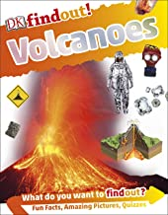Our topic for this half term is **‘Angry Earth!’** This is a **geography** based topic and we will be looking at different natural disasters such as earthquakes, volcanoes, tsunamis and other extreme weathers. We will be learning to:

- use maps, atlases and globes to locate countries and describe features studied

- use the eight points of a compass, four and six-figure grid references, symbols and a key (including the use of Ordnance Survey maps) to build our knowledge of the United Kingdom and the wider world

- describe and understand key aspects of physical geography, including: climate zones, biomes and vegetation belts, rivers, mountains, volcanoes and earthquakes

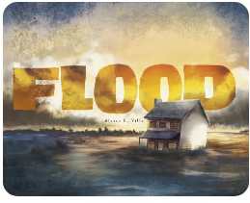- name and locate counties and cities of the United Kingdom, geographical regions identifying human and physical characteristics, key topographical features (including hills, mountains, coasts and rivers), and land-use patterns; and understand how some of these aspects have changed over time

As well as learning about our ‘Angry Earth’, we will be basing our **English** around the text, ‘Flood’ by Alvaro F Villa. Along with enjoying and developing our reading skills from this text, it will inspire us to write, too. We will look closely at how to improve our narrative writing in the format of a diary. We will also learn about explanation texts and explain what happens when a volcano erupts. Using texts in this way will provide the children with a ‘hook’ for their writing and their learning throughout the curriculum and mean that they can fully immerse themselves in this fascinating topic!

In **Maths,** we will continue to develop our work on mental addition, subtraction, number bonds and times tables. In the main part of our lessons, we will focus on decimals and money, before moving onto time. MyMaths homework will be set each week as normal on MyMaths.co.uk and should be completed ready for the following Friday. **Timestables practise and knowing our timestables by heart remains a big focus for Year 4,** please continue to work on this at home with your child.

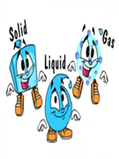In **Science** we will be thinking about the subject ‘States of Matter’ and learning how to:

- compare and group materials together, according to whether they are solids, liquids or gases

- observe that some materials change state when they are heated or cooled, and measure or research the temperature at which this happens in degrees Celsius (°C)

- identify the part played by evaporation and condensation in the water cycle and associate the rate of evaporation with temperature

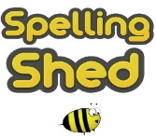**Spellings** will be set, as usual, on the EdShed app. The children will be tested the following Monday. Please ensure your child practises at home. Spelling is a vital part of learning to become a competent writer. It is a very important life skill that we value highly here at St Joseph’s, so please encourage your child to learn their spellings each week.

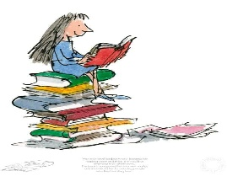

**Reading** is another important life skill that is of highest priority in our school. Our aim is to develop, within our pupils, a lifelong passion for reading. To help us with this we ask that you read for around 10 minutes each night at home. Please ensure your books and reading records are in school every day so that we have the opportunity to also read with you and monitor your reading at home regularly. Each time you read at home, please ensure an adult signs your reading record.

**P.E. in Year 4.**

Please ensure your child has their PE kit in school on the following days:

Class 9 – Monday and Thursday

Class 10 - Monday (P.E.) and Thursday (swimming)

**Class 10** will continue with their swimming lessons every Thursday, so please make sure that they bring their swimming kits with them.

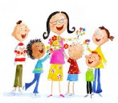We hope that you continue to have an exciting and enjoyable time with us this half term and that you are filled with enthusiasm for your learning. We are looking forward to continuing to work with you and see you grow, develop and progress in your learning.

The Year 4 Team

***“As God’s chosen ones, holy and beloved, clothe yourselves with compassion, kindness, humility, meekness, and patience. Put up with one another and, if anyone has a complaint against another, forgive one another; just as the Lord has forgiven you, so you also must forgive. Above all, clothe yourselves with love, which binds everything together in perfect harmony. And let the peace of Christ rule in your hearts, that is why you belong to the Christian family. And always be thankful.”***

**Colossians 3: 12-15.**