**Year 4 Summer 2 Newsletter**

Welcome back after the half term holiday! We hope you have had a fantastic break and are looking forward to the exciting things lined up for you in this final term!

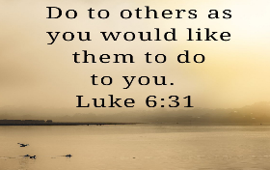In our **Religion** we will be continuing to use our “Come and See” scheme and we will be finishing our module on ‘Building Bridges’. Christians believe that, in Jesus Christ, the world has been reconciled to God. Through and in Christ, every human being is offered the power to reach out in forgiveness and peace, to receive and to offer reconciliation.

We will also start our SRE sessions, ‘Journey in Love’. This unit has allowed us to know and understand that we are all different and celebrate these differences as we appreciate that God’s love accepts us as we are and as we change.

Our final unit in Religion will be ‘God’s People’. Christians believe that the diversity of the world and its people is God’s gift. Jesus in his life and gospel, challenges people to appreciate diversity and to create with it a harmony that reflects the unity of Father, Son and Holy Spirit. This is reflected in the work of CAFOD which is something we will explore together this term.

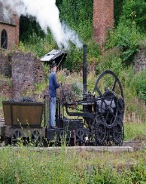Our topic for this half term is ‘Remarkable Railways’. This is a **History** based topic with some **Geography** skills taught alongside. We will be learning about the development of the railways in Great Britain, finding out about the history of the railways and significant early locomotives. We will also investigate some important historical events and learn about some of the key people who were influential in the development of the railways. In addition to this, we will learn about the development of locomotive technology and examine the differences between steam, diesel and electric locomotives. We will use our geographical skills to map out some key routes. Within our topic, we will look at the East Lancashire Railway. The ELR has a long and rich heritage, from all the way back when the very first trains steamed into Bury Station in the 1840s and it passes right in front of our school!

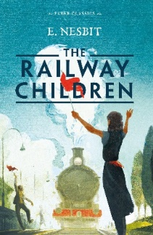As well as learning about ‘Remarkable Railways’, we will be basing our **English** around the text, ‘The Railway Children’ by Edith Nesbit. Along with enjoying and developing our reading skills from this text, it will inspire us to write, too. This text will provide us with a ‘hook’ for our writing and our learning throughout the curriculum, meaning that we can fully immerse ourselves in this fascinating time in our country’s history!

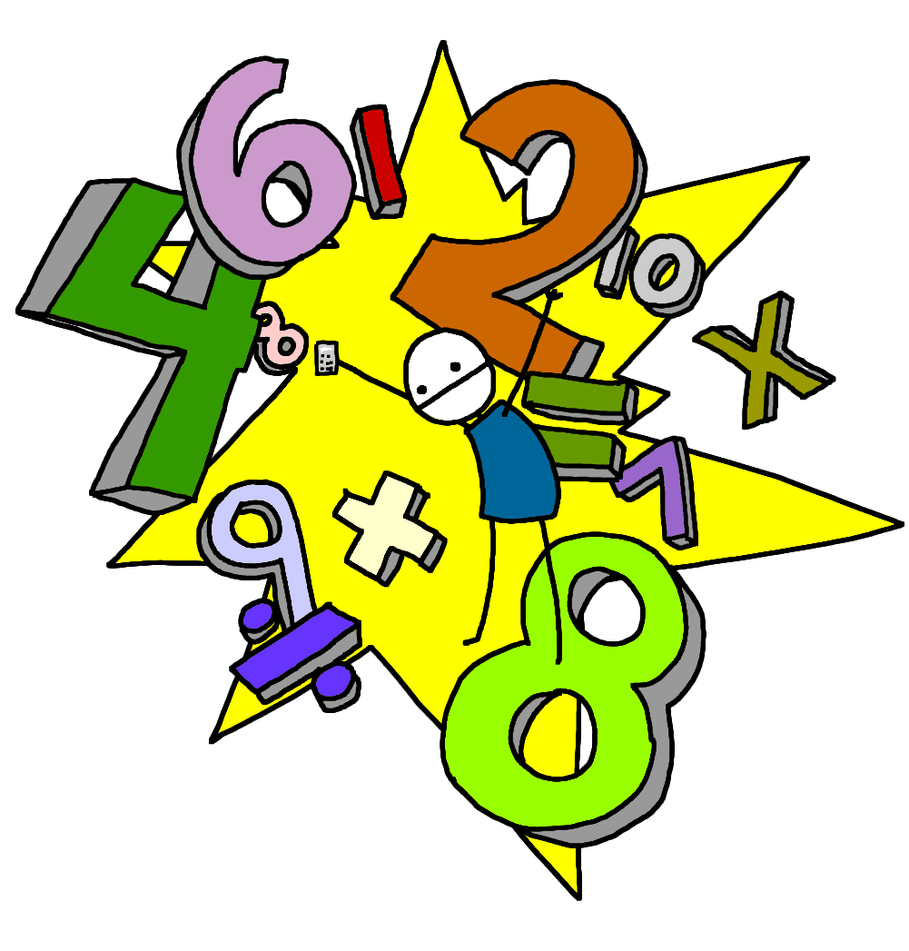

In **Maths,** we will continue to develop our work on mental addition, subtraction, number bonds and times tables. In the main part of our lessons, we will focus on statistics (interpreting charts and line graphs), before moving on to properties of shape and finally geometry (position and direction). MyMaths homework will be set each week as normal on MyMaths.co.uk and should be completed ready for the following Friday.



In **Computing**, we will be covering a unit entitled ‘A repetition in shapes’.This unit will enable us to:

● Design, write and debug programs that accomplish specific goals, including controlling or simulating physical systems; solve problems by decomposing them into smaller parts

● Use sequence, selection, and repetition in programs; work with variables and various forms of input and output

● Use logical reasoning to explain how some simple algorithms work and to detect and correct errors in algorithms and programs

● Select, use and combine a variety of software (including internet services) on a range of digital devices to design and create a range of programs, systems and content that accomplish given goals, including collecting, analysing, evaluating and presenting data and information

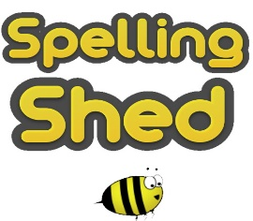

**Spellings** will be set, as usual, on the EdShed app. You will be tested the following week. Please ensure you practise at home. Spelling is a vital part of learning to become a competent writer. It is a very important life skill that we value highly here at St Joseph’s, so please learn your spellings each week.

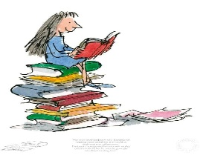**Reading** is another important life skill that is of highest priority in our school. Our aim is to develop, within our pupils, a lifelong passion for reading. To help us with this we ask that you read for around 10 minutes each night at home. Please ensure your books and reading records are in school every day so that we have the opportunity to also read with you and monitor your reading at home regularly. Each time you read at home, please ensure an adult signs your reading record.



**P.E.** will be taught by Mr Riley. Please ensure that you come to school in correct PE uniform on your PE day.

Class 9 have PE on Mondays and Thursdays.

Class 10 have PE on Mondays and Swimming on Thursdays.

We hope that you continue to have an exciting and enjoyable final half term with us and that you are filled with enthusiasm for your learning. We are looking forward to continuing to work with you and see you grow, develop and progress in your learning.

Best wishes for a great final half term,

The Year 4 team

***‘See what great love the Father has for us, that we should be called children of God! And that is what we are!***

***Dear friends, we are already children of God, we know that when Christ appears, we shall be like him, because we shall see him as he is.***

***Everyone who has this hope in Christ, will try to be loving and kind and keep away from anything that is wrong.’***

***1 John 3:1−3***